NetWalk Documentation

---matlab version

This is the document of NetWalk for matlab version. For technical details, please refer to the paper:

NetWalk: A Flexible Deep Embedding Approach for Anomaly Detection in Dynamic Networks. Wenchao Yu, Wei Cheng, Charu Aggarwal, Kai Zhang, Haifeng Chen, Wei Wang. *The Proceedings of the ACM SIGKDD International Conference on Knowledge Discovery and Data Mining (SIGKDD’18)*, 2018.

The entry of running the code are either netwalk_karate.m or netwalk_stream.m. The first one only conducts embedding of nodes in a static network and visualize the 2-dimensional embedding results of nodes. The second one simulates the streaming edges scenario that starts with training with (random sampled) part of the edges in the whole graph, and inject some fake edges to the rest testing edges. Then it feed the algorithm dynamically with different snapshots. Each snapshot conduct one model updating and anomaly edges detection.

**For detailed code description, please refer to html documents in fold ./doc_html**

**Overview**

Massive and dynamic networks arise in many practical applications such as social media, security and public health. Given an evolutionary network, it is crucial to detect structural anomalies, such as vertices and edges whose “behaviors” deviate from underlying majority of the network, in a real-time fashion. Recently, network embedding has proven a powerful tool in learning the low-dimensional representations of vertices in networks that can capture and preserve the network structure. For example, in FIG. 1, in a bank money transfer graph, we can embed account money transfer graph into embedding of users and embedding of transactions(edges). By clustering the embedding representations, we can detect anomalous users (nodes) or anomalous transactions(edges).



0

1

1



+

+

anomalous user

Vertex Anomalies



0

1

1



+

+

anomalous edge

Edge Anomalies

FIG. 1. Anomaly detection in static network (e.g., bank money transfer graph)

However, most existing network embedding approaches are designed for static networks, and thus may not be perfectly suited for a dynamic environment in which the network representation has to be constantly updated. To address the problem, we propose a novel approach, NetWalk, for anomaly detection in dynamic networks by learning network representations which can be updated dynamically as the network evolves. The workflow of the framework is shown in FIG. 2. Basically, there are four major parts: 1). generating network walks by random walk; 2). learning network representations with clique embedding; 3). maintaining network representations incrementally; 4). clustering-based anomaly detection on network representations.



FIG. 2. Workflow of NetWalk for anomaly detection in dynamic networks

Specifically, we first encode the vertices of the dynamic network to vector representations by clique embedding, which jointly minimizes the pairwise distance of vertex representations of each walk derived from the dynamic networks, and the deep autoencoder reconstruction error serving as a global regularization. The illustration of the clique embedding is show in FIG. 3.



FIG. 3. Illustration of clique embedding for one network walk.

is the input vector of vertex in walk

Since we are addressing the dynamic graph in which is keep evolving, we assume we have global node set, and the edges streaming in as time goes by. As illustrated in FIG. 4, we have an initial network, in which all nodes are included. When edges (such as bank transaction, directed or undirected, weighted or unweighted) are streaming in as time goes by asynchronously, how to record information without maintaining whole network structure? How to maintain network representations incrementally as the network topology evolves? Here, we employ a reservoir sampling strategy to achieve that. The vector representations can be computed with constant space requirements using reservoir sampling.



initial network

FIG. 4. Evolution of initial network



FIG. 5. Illustration of updating the reservoirs. Initially we build the reservoir of each vertex based on the network at . When () is added at timestamp , the corresponding reservoirs of and will be updated. Similarly, when is deleted at timestamp , we replace the deleted items with the remaining neighbors of the corresponding vertex.

Given a stream of edges, NetWalk maintains a reservoir for each vertex such that each single item in the reservoir is selected at random from ’s neighbors. The example is shown in FIG. 5.

On the basis of the learned low-dimensional vertex representations, a clustering-based technique is employed to incrementally and dynamically detect network anomalies. An example of dynamically detect anomalous node from an evolving network is shown in FIG. 6. For how to conduct online clustering for anomaly detection, assuming that there are points in an existing cluster and new points at time-stamp to be absorbed by this cluster, the centroid can be updated using:





FIG. 6. Example of anomalous node detection over time

In our tool, the setting is as follows. In the beginning, we sample half of the all edges as the initial training data. For example, FIG. 7. Shows one example of embedding an email network, (a) shows the initial embedding with 50% edges. In snapshot 1, we feed another 25% edges and update node embedding in (b). (c) shows the results after we feed all edges.



FIG. 7. Embedding results on Email network. Vertex colors represent a modularity-based clustering on the input graph. (a) initial embedding with 50% edges, (b) online embedding with additional 25% edges (75% edges in total), (c) online embedding with additional 25% edges (100% edges in total).

The whole pipeline is shown in FIG. 7.

Dynamical network sequence

**10**

**13**

**11**

Update walk Reservoirs

Online Clustering

Learning network nodes Codes

**12**

Edge Encoding

New edge coming

**14**

Real-time

Anomaly Detection

FIG. 8. The pipeline of NetWalk for anomalous node detection

Edge Encoding

Learning Graph Codes

Update Vertex Reservoirs

**25**

We build a lookup table to perform new edge(s) encoding in real-time based on the graph codes we learned. Assume the network nodes codes learned deep autoecoding algorithm is F, each vertex vi is encoded as a d-dimension vector Fi. For each new edge euv where u is the source vertex, and v is the destination vertex, it will be encoded as Fu ○ Fv . Here, ○ is the Hadamard operator. The edge list codes are denoted as E, where m is the number of edges. We use Euclidean distance to measure similarity between two edge codes.

**21**

**22**

We transform vertex to vector using deep auto-encoding with regularization.

Initialed by building a vertex Reservoirs indexing network walkers sampled from the network

**23**

We formulate the network nodes codes learning problem as an optimization problem.

**22**

Updating reservoirs when new edges are coming by searching for relevant indices

**13**

**14**

Real-time

Anomaly Detection

Online Clustering

**28**

**26**

We use the dynamical clustering algorithm that is able to handle streaming in edges.

If the new vertex or edges are far from all current clustering center, then it will be claimed as abnormal.

**27**

Initially, the training data points collected from the initial graph are grouped into k clusters using k-means algorithms. The center of each cluster is updated by formula below. 

**16**

FIG. 9. Tree diagram of different modules.

**Code Input/Output**

We provide two different entry file: netwalk_stream.m and netwalk_karate.m.

netwalk_stream.m simulates stream edge online updating of node embedding and output AUC score of anomaly detection, while netwalk_karate.m only embeds a static network into 2-dimentional space for visualization.

**Input:**

1. For netwalk_stream.m, the input is Graph(network) file with sparse format:

For example, the given example file is at ./data/ucsocial/out.opsahl-ucsocial

1 2 1 1082008561

3 4 1 1082123439

5 2 1 1082381991

6 7 1 1082407219

.

.

.

First column: ID of from node

Second column: ID of to node

Third column: edge weight

Fourth column: timestamp of the edge

1. For netwalk_karate.m, the input is the linked list format.

For example, the ./data/ karate.adjlist is with following format:

1 2 3 4 5 6 7 8 9 11 12 13 14 18 20 22 32

2 1 3 4 8 14 18 20 22 31

3 1 2 4 8 9 10 14 28 29 33

.

.

.

format:

startNodeID endNodeID1 endNodeID2 …..

**output:**

1. For netwalk_stream.m, the output: auc score of anomaly detection at different snapshots;

[10/27/18 21:53:11] loading dataset uci_message...

[10/27/18 21:53:11] generating anomalous dataset...

[10/27/18 21:53:11] initial network edge percent: 50.0%, anomaly percent: 5.0%.

[10/27/18 21:53:11] netwalk generation for staic graph...

[10/27/18 21:53:11] walk length: 3, samples per node: 10.

[10/27/18 21:53:11] initial graph walk generation time 0.41 (s).

[10/27/18 21:53:11] initial graph embedding time 0.02 (s).

[10/27/18 21:53:11] edge encoding...

[10/27/18 21:53:11] anomaly detection...

[10/27/18 21:53:11] auc score testing: 0.36.at snapshot:0

[10/27/18 21:53:14] edge encoding...

[10/27/18 21:53:14] anomaly detection...

[10/27/18 21:53:14] auc score testing: 0.39.at snapshot:1

.

.

1. For netwalk_karate.m, the output is the visualization of node embedding, as shown in FIG. 10.

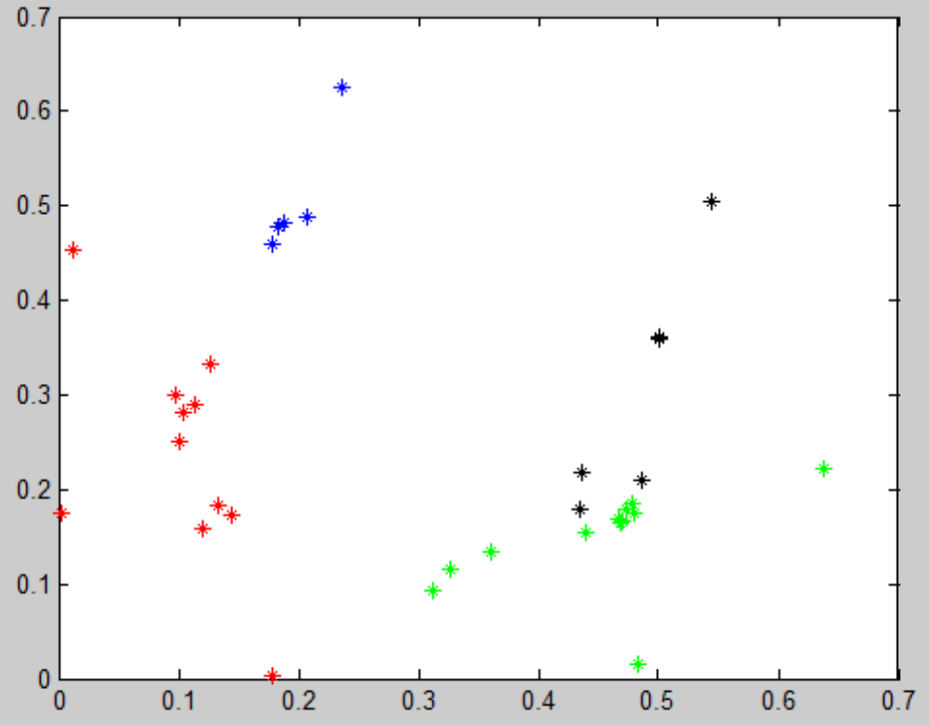

FIG. 10 2-dimensional embedding of karate network

**Code Structure**

Below is the code structure of netwalk_stream.m which shows the pipeline of the whole logic of using NetWalk for dynamic network abnormal edges detection. The code documents of other files are included in doc_html fold.

**Contents**

* clear and add folder
* hyperparameters
* data sets
* initial graph
* inject anomaly
* simulate different snapshots in a streaming way
* different datasets' loading
* generate anomaly
* initial graph walk generation
* initial embedding
* Conduct netwalk embedding in the initial network(graph)
* edge encoding and clustering
* static anomaly detection in the initial network
* dynamically streaming in batch of edges in sequential snapshots

**clear and add folder**

add folder to current working directory

clear; clc;

addpath loading/ framework/ optimize/

Warning: Name is nonexistent or not a directory: loading

**hyperparameters**

---------------------------------------------

parameter symbol default value

---------------------------------------------

walk_len l 3

sample_per_node k 20

ini_graph_percent 20%

snapshot_edge m 100

anomaly_percent 5%

% rng(1);

**data sets**

* uci_message

* arXiv hep-th

* Digg

* DBLP

Here, we use uci_message for example;

dataset = 'uci_message';

**initial graph**

we only select part of the edges to included in the network

for initial training, all the remaining edges are treated as

testing edges coming in a streaming way

ini_graph_percent = 0.5;

**inject anomaly**

all anomaly edges are randomly generated that are not

shown in the original network(grand-truth networ) and inject them in the

testing edges

anomaly_percent = 0.05;

**simulate different snapshots in a streaming way**

number of edges in each sanpshot for updating learning model

snapshot_edge = 500;

walk_len = 3; % number of nodes in one walk

sample_per_node = 10; % number of walk's for each node

d = 5; % number of hidden layer

rho = 0.2; % rho, spasity parameter

gama = 30; % weight of autoencoder (reconstruction error)

beta = 0.2; % weight of sparsity regularization

lamda = 5e-4; % weight decay parameter

k = 10; % kmeans clustering

[10/27/18 15:36:18] loading dataset uci_message...

**in case that the original graph is too dense, we can subsample of edges**

for experiments

sample_rate = 0.1;

**different datasets' loading**

switch dataset

case 'uci_message'

% % <matlab:function [data, n, m] = load_uci_message(sample_rate)>

[data, n, m] = load_uci_message(sample_rate);

case 'digg'

[data, n, m] = load_digg(sample_rate);

case 'hep_th'

[data, n, m] = load_hep_th(sample_rate);

case 'dblp'

[data, n, m] = load_dblp(sample_rate);

end

**generate anomaly**

split the whole graph into training network which includes parts of the whole graph edges(with ini_graph_percent) and testing edges that includes a ratio of manually injected anomaly edges, here anomaly edges mean that they are not shown in previous graph;

[synthetic_test, train_mat, train] = anomaly_generation(ini_graph_percent, anomaly_percent, data, n, m);

[10/27/18 15:36:18] generating anomalous dataset...

[10/27/18 15:36:18] initial network edge percent: 50.0%, anomaly percent: 5.0%.

**initial graph walk generation**

tic

[walks_onehot, reservoir, degree, walks] = netwalk_generation(train_mat, n, walk_len, sample_per_node);

fprintf('[%s] initial graph walk generation time %.2f (s).\n', datestr(now, 'mm/dd/yy HH:MM:SS'), toc)

[10/27/18 15:36:18] netwalk generation for staic graph...

[10/27/18 15:36:18] walk length: 3, samples per node: 10.

[10/27/18 15:36:18] initial graph walk generation time 0.19 (s).

**initial embedding**

invoke initialization function for parameters in the embedding network to be optimized, here initialize(d,n) is using one layer for encoding and another layer for decoding. If you use 6 layers(3 encoding+ 3 decoding), please use initialize_deep(d, n) function instead. Note that in current version, the total number of layers in the learning network is hard coded with 2 layers or 6 layers only.

%% method selection, both 'fast' and 'scalable' are 2 layer neural network

%  'fast' is faster than 'scalable' but uses more memory, for large graph,

%  typically use 'scalable'. 'deep' is the method with 6 layers in the

%  neural network, 3 layers encoding and 3 layers decoding

options.method = ‘fast’; % using 2 layer fast version for embedding

switch options.method

case 'fast'

options.theta = initialize(d, n); % options.theta includes all parameters to optimize

case 'scalable'

options.theta = initialize(d, n); % options.theta includes all parameters to optimize

case 'deep'

options.theta = initialize_deep(d, n); % options.theta includes all parameters to optimize

end

options.dataset = dataset; % name of dataset

options.ini_graph_percent = ini_graph_percent; % percentage of deges selected in the initial network for model training

options.anomaly_percent = anomaly_percent; % percentage of edges in testing edge pool to be injected anomalies

options.walk_len = walk_len; % number of nodes in one walk

options.sample_per_node = sample_per_node; % number of walk's for each node

options.d = d; % number of hidden layer

options.rho = rho; % rho, spasity parameter

options.gama = gama; % weight of autoencoder (reconstruction error)

options.beta = beta; % weight of sparsity regularization

options.lamda = lamda; % weight decay parameter

options.n = n; % number of nodes in the whole network

options.m = m; % number of total edges in the whole network

options.walks_onehot = walks_onehot;% onehot vectors in all sampled walks

options.snapshots = 0; % snapshot id, start from 0 for initial graph

tic

**Conduct netwalk embedding in the initial network(graph)**

The initial network includes part of edges(e.g., 0.5 percentage of all edges)

[embedding, opttheta] = netwalk_embedding( options );

% embedding \in R^ n*d

% plot(embedding(:,1),embedding(:,2),'.')

fprintf('[%s] initial graph embedding time %.2f (s).\n', datestr(now, 'mm/dd/yy HH:MM:SS'), toc)

[10/27/18 15:36:18] initial graph embedding time 0.01 (s).

**edge encoding and clustering**

**static anomaly detection in the initial network**

The test edges are the top-ranked 100 edges in the testing edge pool

[scores, auc, n0, c0 ] = anomaly_detection(embedding, train, synthetic_test(1:100,:), k);

fprintf('[%s] auc score testing: %.2f.\n', datestr(now, 'mm/dd/yy HH:MM:SS'), auc)

[10/27/18 15:36:18] edge encoding...

[10/27/18 15:36:18] anomaly detection...

[10/27/18 15:36:18] auc score testing: 0.23.

**dynamically streaming in batch of edges in sequential snapshots**

% calculate number of snapshots for upcoming new edges

snapshots = floor(length(synthetic_test)/snapshot_edge);

old_walks = walks;

% simulating batch of new edges streaming in

% each snapshot conducts one model updating, each snapshot includes

% $snapshot_edge$ of edges

for i = 1:snapshots

start_idx = (i-1)*snapshot_edge + 1;

end_idx = i*snapshot_edge;

new_edges = synthetic_test(start_idx:end_idx, :);

new_walks = [];

for e = 1:length(new_edges)

% first update node degrees

% refer Section 3.4 of KDD paper

node_in = new_edges(e,1);

node_out = new_edges(e,2);

degree(node_in) = degree(node_in) + 1;

degree(node_out) = degree(node_out) + 1;

% update reservoir of src node -- be careful when update new vertex

tmp_reservoir_src = datasample(1:degree(node_in), sample_per_node);

reservoir(node_in, tmp_reservoir_src == degree(node_in)) = node_out;

% update reservoir of dst node

tmp_reservoir_dst = datasample(1:degree(node_out), sample_per_node);

reservoir(node_out, tmp_reservoir_dst == degree(node_out)) = node_in;

% generate new walks for src node

idx_src = find(tmp_reservoir_src == degree(node_in));

new_walks_src = [repmat([node_in node_out], length(idx_src) * sample_per_node, 1), datasample(reservoir(node_out,:), length(idx_src) * sample_per_node)'];

% generate new walks for dst node

idx_dst = find(tmp_reservoir_dst == degree(node_out));

new_walks_dst = [repmat([node_out node_in], length(idx_dst) * sample_per_node, 1), datasample(reservoir(node_in,:), length(idx_dst) * sample_per_node)'];

% one hot encoding

new_walks = [new_walks; new_walks_src; new_walks_dst];

end

% 0.1 percentage of old walks will be maintained and added with new

% generated walks for new edges

sample_old_walk = datasample(old_walks, floor(length(old_walks) * 0.1), 'Replace',false);

new_walks = [sample_old_walk; new_walks];

flat_walk = new_walks';

new_walks_onehot = sparse(flat_walk(:), 1:length(new_walks) * walk_len, ones(length(new_walks) * walk_len,1), n, length(new_walks) * walk_len);

% update walks_onehot that includes new walks information for re-training

options.walks_onehot = new_walks_onehot;

% warm-up initialization for model updating with new training data

options.theta = opttheta;

% record new snapshot id

options.snapshots = i;

% recalculating node embeddings with new traing data(walks)

[embedding, opttheta] = netwalk_embedding( options );

% calculate anomaly detection auc after adding new batch of edges

[scores, auc, n0, c0] = anomaly_detection_stream(embedding, train, new_edges, k, 0.1, n0, c0);

% update old walks

old_walks = new_walks;

end

[10/27/18 15:36:19] edge encoding...

[10/27/18 15:36:19] anomaly detection...

**Important Parameters**

sample_per_node = 10;%50;This is the hyper-parameter for denoting how many walks aresampled from each node. In our experiments, we used 50. For fast run the code, you can use 10 instead.

sample_rate = 0.1;% 1;

% in case that the original graph is too dense

% we can subsample of edges for experiments. In our experiments, we use 1. For fast run the code, you can use 0.1 instead.